Fundraising Materials
Order From
Your Details
First Name: Click or tap here to enter text.
Surname: Click or tap here to enter text.
Address: Click or tap here to enter text.
Phone number: Click or tap here to enter text.
Email address: Click or tap here to enter text.

Order Details
Choose the items you wish to order below. You can find photos of some of the key items on the next page.
Please only order what you will use to reduce unnecessary costs to our charity.
Product | Quantity | Size (if app)
T-shirt (S, M, L, XL)*
Cycling jersey (S, M, L, XL)*
Running vests - Male (S, M, L, XL)*
Running vests - Female (S, M, L, XL)*
Tote Bags
Cardboard Collection Boxes
Plastic Collection Tins
Sunflower Pin Badges
Banners
Pens
Balloons
Bang Bang Sticks
Wristbands
A4 Blank Event Poster (to promote your event)
Sponsorship Form

*You can only be allocated one t-shirt/jersey or cycling vest per fundraiser.

You should receive your items within 7 working days. If you have not received your order after this time, please get in touch at fundraising@sruk.co.uk. / 020 3893 5998

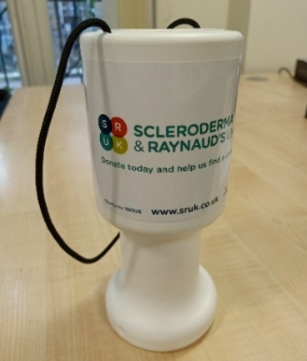  Plastic collection tin | 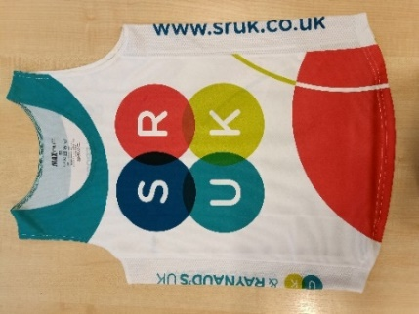  Running vest
Cardboard collection box | Sunflower pin badge
Pens | Bang bang sticks
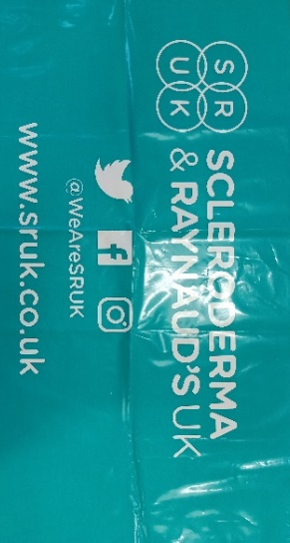  Banner | Wristband
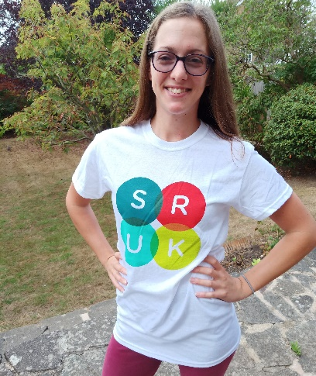T-shirt

