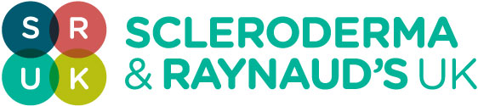

Scleroderma & Raynaud’s UK Annual Conference 2016
Saturday 3rd September, 2016
ILEC
PROGRAMME OF EVENTS

Time | Session | Speakers
09:30-10:00 | Conference registration & Coffee
10:00-10:15 | Welcome and update | Prof Jeremy Pearson  Sue Farrington
10:15-10:45 | Political engagement & the impact of chronic disease on work | Prof. Dame Carol Black
10:45-11:25 | Recent clinical trials & effective treatments for Scleroderma & Raynaud’s | Prof. Chris Denton
11:25 – 11:40 | Coffee Break/Exhibitors
Interactive group sessions: Delegates choose 2 of the 3 sessions

11:40 – 12:10  12:10 – 12:40 | Finger problems related to Raynaud’s and Scleroderma  Techniques for managing pain  GI treatments and nutrition | Prof. Ariane Herrick (Main Hall)  Will Gregory (Break Out Room 1)  Dr. Charles Murray (Break Out Room 2)
12:40-13:25 | Lunch/exhibitors (45 mins)  ‘Complimentary medicine zones’ 2 x 10min sessions are available
13:25 – 14:25 | Stem cell therapy explained  Stem cell transplant – My story | Prof Alan Tyndall  Katrina Brown
14:25 – 14:30 | Rest Break
Interactive group sessions: Delegates choose 2 of the 3 sessions
14:30 – 15:00  15:00 - 15:30 | Techniques for evaluating Raynaud’s  The impact of systemic sclerosis – similarities and differences between limited and diffuse skin disease  Coping with your condition & understanding mindfulness | Dr. Kevin Howell (Break Out Room 1)  Dr. John Pauling (Break Out Room 2)  Miss Sarah Leggett  Dr. Oliver Wilkinson (Main Room)
15:30 – 15:45 | Coffee Break/Exhibitors
15:45– 16:25 | Research into biomarkers | Dr. Francesco Del Galdo
16:25 – 16:55 | Setting the research agenda | Prof. Chris Denton, Prof Jeremy Pearson and Sue Farrington
16:55 – 17:00 | Thank you and close | Chair
17:00 – 17:30 | Final networking opportunity – Departure Drinks

